# RetailerDemo

*This specification was generated from a specification-only editor. Item identifiers, data sources and action statements were edited and error checked interactively while working within the UI designer and editor.*

*All italicised text is commentary. Black text is part of the original specification. Red text has been added here for explanation of this specification sample.*

# Host: Cloud

Page 7

## Start.form

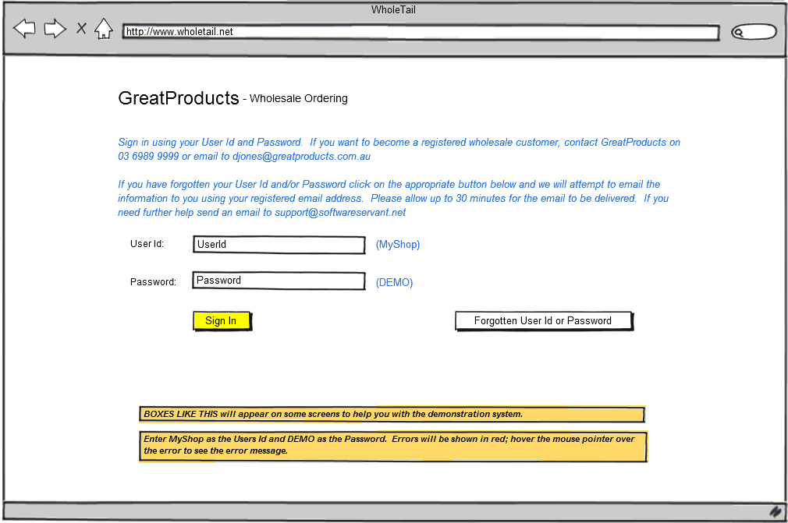

*When the [Sign In] button is clicked do the specified actions …*

[Sign In] Error if UserId = Nothing or Password = Nothing

-Heading = UserId

-Message = 'You must enter a User Id and Password'

Load Customer

Error if Customer.Password <> Password

-Heading = UserId

-Message = 'Sign-In process failure. Check password and try again’

Load orders for this customer

>Orders.form if customer has orders

>Customer.form

[Forgotten User Id or Password] >Forgot.form

**End of Start.form**

## Customer.form

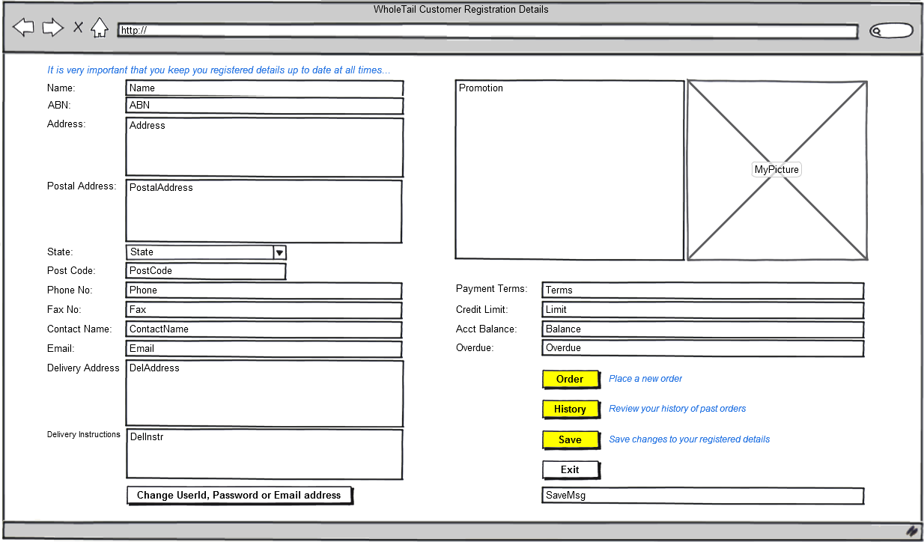

*Items ending in : below (eg. Name: ) refer to identifiers on form above. It is a basic requirement of the method that all dynamic data items are identified with a source. Stakeholders are introduced to this by the project leader and quickly understand it.*

Name : Customer.Name *input item Name is bound to database item Customer.Name*

ABN : Customer.ABN *“*

Address : Customer.Address “

PostalAddress : Customer.PostAddress

State : Customer.State *database item Customer.State will display in State input box*

droplist State.Name *all the state names will be listed when dropdown icon is clicked*

PostCode : Customer.PostCode

Phone : Customer.Phone

Fax : Customer.Fax

ContactName : Customer.Contact

Email : Customer.Email{ReadOnly} *this item is read-only and cannot be changed*

DelAddress : Customer.DelAddress

DelInstr : Customer.DelInstruct

Promotion : Supplier.Promo{ReadOnly}

MyPicture : Supplier.Img

Terms : Customer.PayTerms{ReadOnly}

Limit : Customer.CreditLimit{ReadOnly}

Balance : Customer.Balance{ReadOnly}

Overdue : Customer.Overdue{ReadOnly}

SaveMsg : ReadOnly a *message is displayed here when the order is saved*

*[Order] below represents the button on the form above and is followed by specification statements that describe what happens when that button is clicked…*

[Order] Load all Products

RestoreSavedOrder  *Restore any unfinished order*

If Customer has a SavedOrder

CalculateOrderTotals

>Review.form

ProductGroup = 'All' *Show all products in RetailShop.form*

BrandName = 'All'

>RetailShop.form

[History] Load orders for this customer

>Orders.form

[Save] SaveMsg = 'Registered details updated ' & Now

[Exit] >End

**End of Customer.form**

## Orders.form

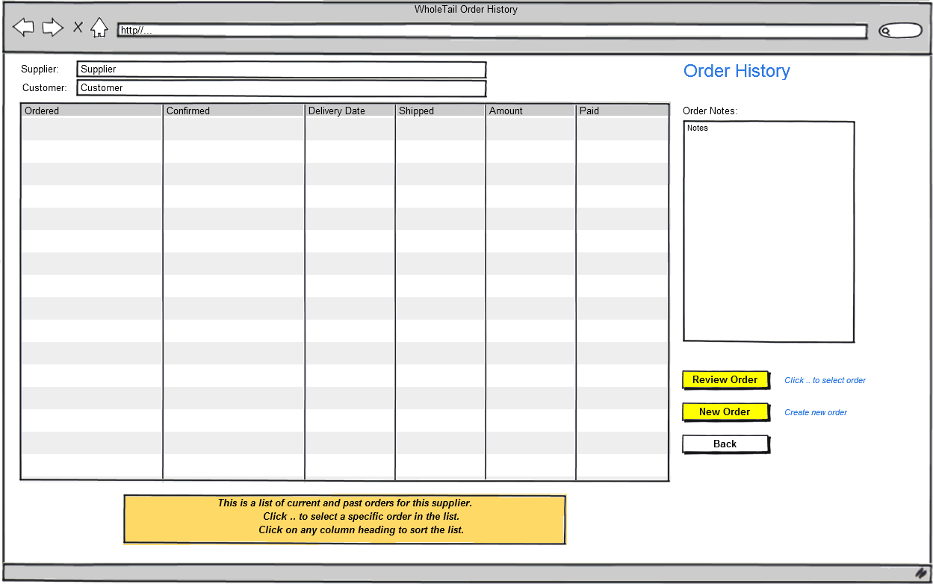

Supplier : Supplier.Name{ReadOnly}

Customer : Customer.Name{ReadOnly}

List each Order

Ordered : Order.OrdDate(24) *(24) shows 24 hour time*

Confirmed : Order.Confirmed(24)

Delivery Date : Order.DelDate(d) *(d) shows short date, eg. 20/11/2023*

Shipped : Order.InvDate(d)

Amount : Order.Total(0.00) *(0.00) shows amounts like 1234.90*

Paid : Order.Paid(0.00)

Notes : Order.Notes

[Review Order] Load OrderItems for this Order

>OrderDetails.form *displays the details for the order*

[New Order] Load all Products

ProductGroup = 'All' *show all products in RetailShop.Form*

BrandName = 'All'

RestoreSavedOrder

>RetailShop.form if SavedOrder.Id = Nothing *no saved order*

CalculateOrderTotals

>Review.form *review saved order*

[Back] >Customer.form

**End of Orders.form**

## OrderDetails.form{ReadOnly}

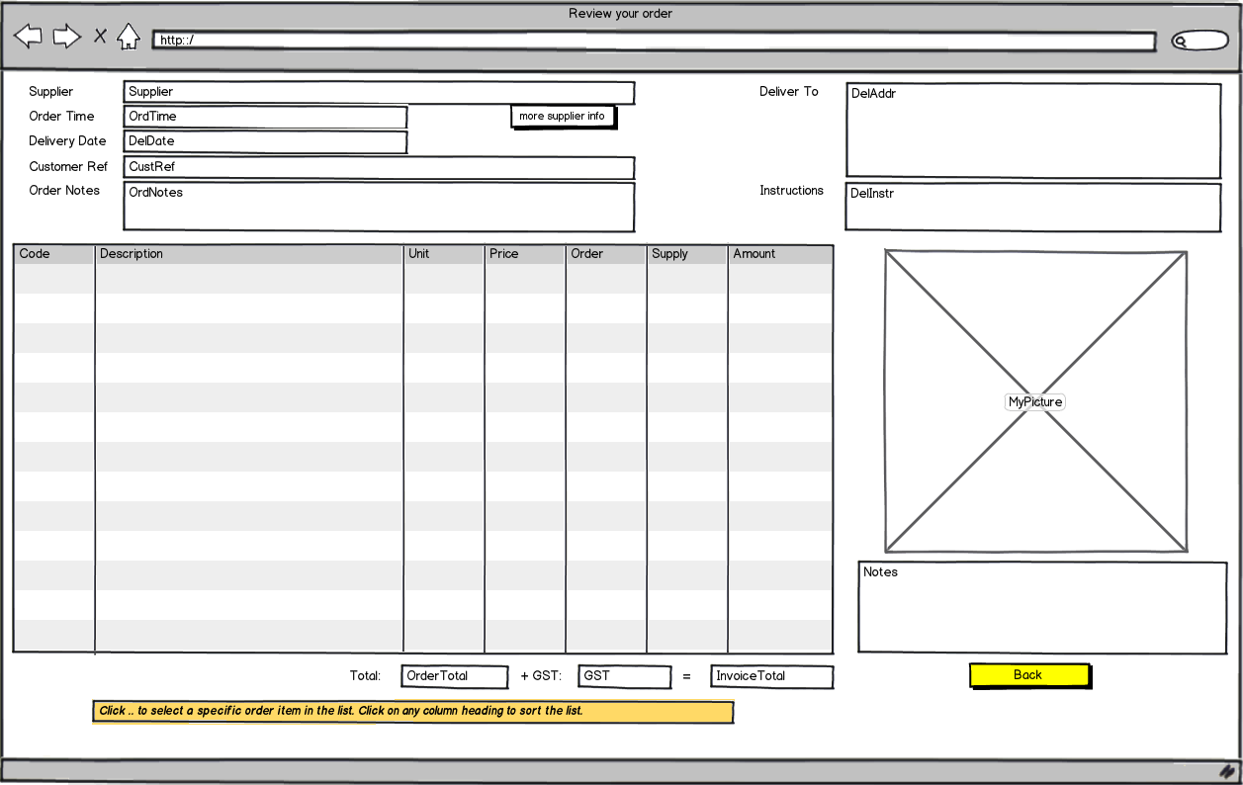

Supplier : Supplier.Name

OrdTime : Order.OrdDate(24) *24 hour format*

DelDate : Order.DelDate(d) *short date format*

CustRef : Order.CustRef

OrdNotes : Order.Notes

DelAddr : Order.DelAddress

DelInstr : Order.DelInstruct

OrderTotal : Order.Amount(0.00)

GST : Order.GST(0.00)

InvoiceTotal : Order.Total(0.00)

List each OrderItem

Code : OrderItem.Code

Description : OrderItem.Description

Unit : OrderItem.Unit

Price : OrderItem.Price(0.00)

Order : OrderItem.OrdQty

Supply : OrderItem.DelQty

Amount : OrderItem.Amount(0.00)

MyPicture : OrderItem.Pic

Notes : OrderItem.Notes

[Back] >Orders.form

**End of OrderDetails.form**

## RetailShop.form

*Displays images of products. Products can be limited to brand and/or product group or searched by any part of product description. Select product to place order.*

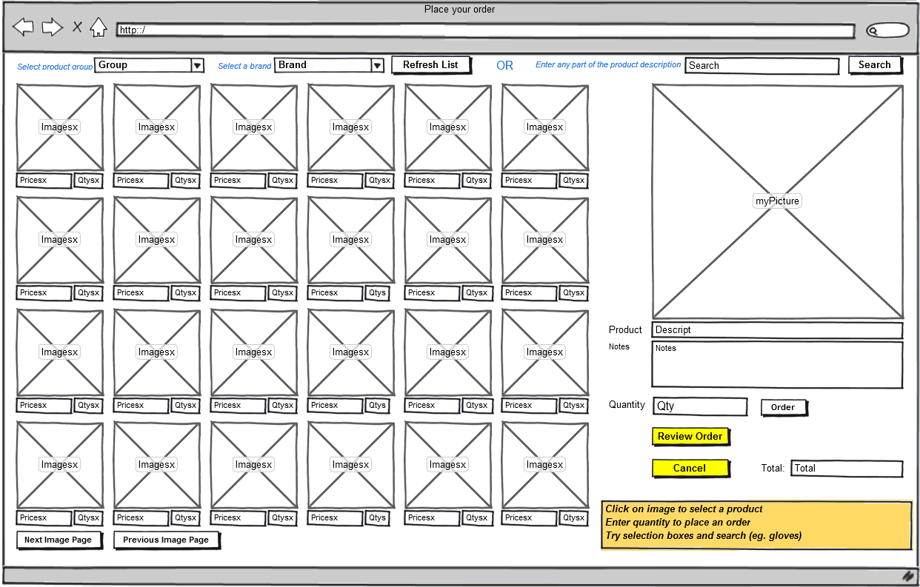

Group : ProductGroup *Product group set before calling this form*

DropList ProductGroup.Name *Product group names can be dropped down for selection*

Brand : BrandName

DropList Brand.Name

Imagesx : Product.Img *Applies to each displayed product*

Pricesx : Product.Price(0.00)

Qtysx : Product.OrderQuantity

myPicture : Product.Img *Applies to the currently selected product*

Descript : Product.Description{ReadOnly}

Notes : Product.Notes{ReadOnly}

Qty : Product.OrderQuantity

Total : GrossTotal(C)

[Next Image Page] *show next images*

[Previous Image Page] *show previous Images*

[Order] Save selected Product

CalculateOrderTotals

Reload saved Product

[Refresh List] Load Products for this Brand if BrandName <> 'All' and_

ProductGroup = 'All'

Load Products for this Group if BrandName = 'All' and_

ProductGroup <> 'All'

Load Products for this Brand and Group if BrandName <> 'All' and_

ProductGroup <> 'All'

Load all Products if BrandName = 'All' and_

ProductGroup = 'All'

[Search] SaveThisOrder

MySearch = '%' & Search & '%'

Load requested products

RestoreSavedOrder

[Review Order] Save selected Product

CalculateOrderTotals

>Review.form

[Cancel] Delete each SavedOrder

>Customer.form

**End of RetailShop.form**

*This page would look like this …*

## Picture 1483829621

## Review.form

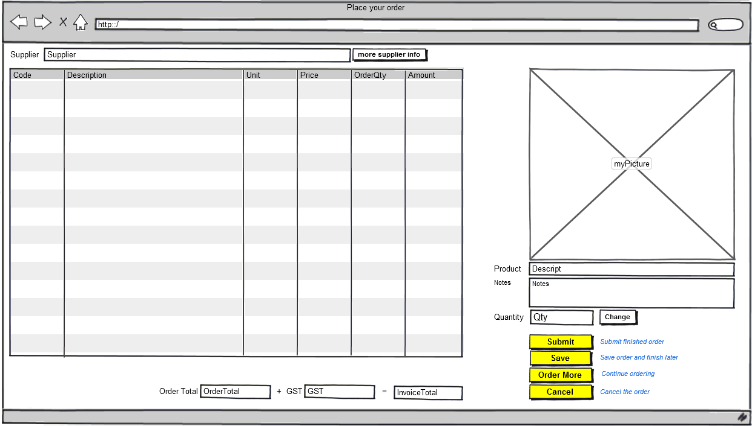

Supplier : Supplier.Name

OrderTotal : TotalAmount(0.00)

GST : GSTamount(0.00)

InvoiceTotal : GrossTotal(C)

List each Product where OrderQuantity > 0

Code : Product.Code

Description : Product.Description

Unit : Product.Unit

Price : Product.Price(0.00)

OrderQty : Product.OrderQuantity

Amount : Product.OrderValue(0.00)

myPicture : Product.Img

Descript : Product.Description{ReadOnly}

Notes : Product.Notes{ReadOnly}

Qty : Product.OrderQuantity

[Change] CalculateOrderTotals

[Submit] >End *Demo only*

[Save] SaveThisOrder

>Customer.form

[Order More] SaveThisOrder

Reload saved Product

>RetailShop.form

[Cancel] Delete each SavedOrder

>Customer.form

**End of Review.form**

## Forgot.form

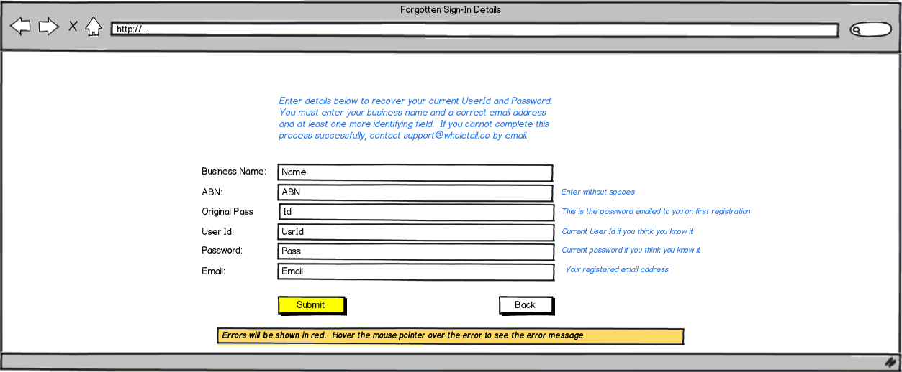

[Submit] Error -Heading = Email

-Message = 'Demo system only. Return with Back'

[Back] >Start.form

**End of Forgot.form**

## CalculateOrderTotals.process

TotalAmount = 0

GSTamount = 0

GrossTotal = 0

SaveThisOrder

Load all products

For each Product

If Product.OrderQuantity <> 0

Product.OrderValue = Product.OrderQuantity * Product.Price

TotalAmount = TotalAmount + Product.OrderValue

EndIf

Next

GSTamount = TotalAmount * 0.1

GrossTotal = TotalAmount + GSTamount

**End of CalculateOrderTotals.process**

## SaveThisOrder.process

*Before the selected set of products changes we save the current order details*

For each Product where OrderQuantity > 0

SavedOrder.Quantity = Product.OrderQuantity if Product is in SavedOrder

Create SavedOrder if Product is not in SavedOrder

-CustId = Customer.Id

-ProdId = Product.Id

-Quantity = Product.OrderQuantity

Next Product

**End of SaveThisOrder.process**

## RestoreSavedOrder.process

*After loading a new set of products, we restore the current order details*

For each SavedOrder

Get Product for this SavedOrder

Product.OrderQuantity = SavedOrder.Quantity

Product.OrderValue = Product.OrderQuantity * Product.Price

Next

**End of RestoreSavedOrder.process**

## Lexicon:

*The lexicon is optional. It enables easy-to-read phrases (left element) to be used in the specification. The right element contains the information that is used in the running application. This section is normally prepared by the project leader/facilitator.*

Product for this SavedOrder : Product.Id = SavedOrder.ProdId

Product is in SavedOrder : Product.Id = SavedOrder.ProdId

Product is not in SavedOrder : Product.Id = SavedOrder.ProdId

Load empty Order table : xSELECT * FROM Order

Load orders for this customer : SELECT * FROM Order WHERE CustId = [Customer.Id]_

ORDER BY OrdDate DESC

Load OrderItems for this Order : SELECT * FROM OrderItem WHERE OrderId = [Order.Id]

Load all Products : SELECT * FROM Product

Load Products for this Brand : SELECT * FROM Product WHERE_

BrandName = [BrandName]

Load Products for this Group : SELECT * FROM Product WHERE_

ProdGroup = [ProductGroup]

Load Products for this Brand and Group : SELECT * FROM Product WHERE_

ProdGroup = [ProductGroup] and BrandName = [BrandName]

Load requested products : SELECT * FROM Product WHERE Description LIKE [MySearch]

**End of Lexicon**

## Data Storage and Access:

*This section is optional but commonly used..*

*If you are working from existing data sources, you can specify a friendlier name and associate it with a more obscure database name (eg. Customer Table: database name=LondonCust004).*

*If developing new database tables or new columns, they will be specified here; these generally fall automatically out of the specification-only design process. All data items are checked for validity during the process and new databases, tables, columns can be created and updated automatically or via generated scripts.*

*This app is using the default cloud database. An alternative database name and connection details could be specified here.*

*The Select Command for each of the tables below specifies which rows are initially loaded from those tables.*

**DBMS: Cloud**

Customer Table

Select Command: SELECT * FROM Customer WHERE UsrId = [Usr] AND Pass = [Passwd]

ProductGroup Table

Select Command: SELECT * FROM ProductGroup

State Table

Select Command: SELECT * FROM State

SavedOrder Table

Select Command: SELECT * FROM SavedOrder WHERE CustId = [Customer.Id]

**End of Host**

**End of Specification**