# MultiMerge

*(Turn on Document Map in View menu to easily navigate this document)*

*This is a small but very powerful specification. It solved a complex problem that the client and incumbent product vendors and systems integrators had been wrestling with for years. It uses the clients domain knowledge, data collections and language; and integrates with their chosen charting tool. The specification language was extended to interact with key Link Explorer (“LE”) properties and actions.*

## Introduction

*This application displays a menu of queries that can be called by analysts at any point in their workflow. A Link Explorer chart will be displayed in response. Where analysts suspect that separately displayed entities are really the same entity, they can merge those entites for a single view; they can also look inside an already merged entity and undo the merge if they wish.*

# Host: PcClient

**Link Explorer Template:** Multi_Merge *this will call the correct LE charting template*

## Start.Form

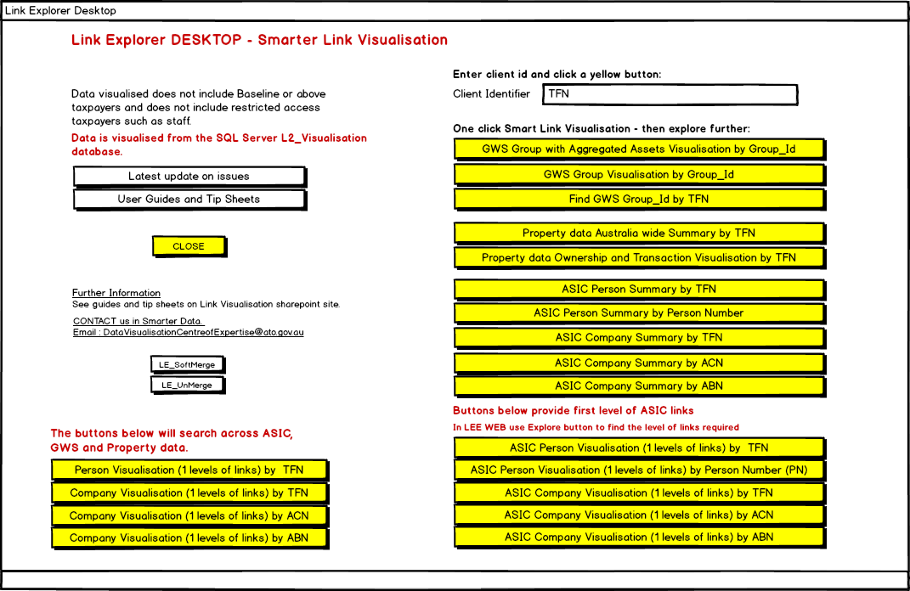

TFN : ThisId *Equates ThisId to the entered TFN so that it’s easier to identify in the spec text*

*The button names below that start with LE_ indicate icon buttons that will appear as options in the Link*

*Explorer charting product.*

[LE_SoftMerge] Icon = 'arrow_join.png' *this icon will show in Link Explorer*

Description = 'Soft-Merge selected objects' *displayed when you click the icon*

Enablement = 'SelectedObjects' *multiple objects selected in Link Explorer*

*The actions below will be executed when the icon button is clicked*

AddMergeSourceToCandidate = False

If SingleTable = True

MergeTable = ObjectClass *objectclass selected in Link Explorer*

If Candidate.Count = 1

Error if ObjectClass <> 'ASIC_Company' and ObjectClass <> 'ASIC_Person'_

and ObjectClass <> 'Prop_Entity'

-Heading = 'Auto-Merge based on TFN'

-Message = 'Can only auto-merge a Company or Person'

Load matching Property TFN if ObjectClass = 'Prop_Entity'

Load matching ASIC TFN if ObjectClass <> 'Prop_Entity'

Error if Candidate.Count < 2

-Heading = 'Auto-Merge based on TFN'

-Message = 'No matching objects to merge'

AssignMergeType.Process

Candidate.Process if SingleTable <> True

Merge.Process

[LE_UnMerge] Icon = 'arrow_split.png'

Description = 'UnMerge the selected (merged) object'

Error if SServant.PreMerge = True

-Heading = 'Soft-Merge'

-Message = 'Soft-Merge disabled while Pre-Merge in process'

UnMerge.Process

[GWS Group with Aggregated Assets Visualisation by Group_Id]

Error if ThisId = Nothing

-Heading = 'ERROR'

-Message = 'You must enter a Client Identifier'

MergeTables = 'GWS_Entity'

QueryIdCol = Nothing

LEtemplate -Name = 'Multi_Merge.twf'

-ODBC = 'Visualisation_L2'

LEchart -Name = 'FindGroupAggAssetsfromGWSby GroupId'

-Type = 'link'

-Layout = 'layered'

-Identifier = ThisId

[Property data Australia wide Summary by TFN] >Error if ThisId = Nothing

-Heading = 'ERROR'

-Message = 'You must enter a Client Identifier'

MergeTables = 'Prop_Entity'

QueryIdCol = 'Matched_TFN'

LEtemplate -Name ='Multi_Merge.twf'

-ODBC = 'Visualisation_L2'

LEchart -Name = 'PROPSummarybyPropertyEntityTFN'

-Type = 'link'

-Layout = 'layered'

-Identifier = ThisId

[User Guides and Tip Sheets] Link to '\\prod.net.gov\netshares$\analysttoolbox\Link_Explorer'

[Latest update on issues] Link to '\\prod.net.gov\netshares$\analysttoolbox\Link_Explorer\Current_Issues.txt'

[ASIC Person Summary by TFN]

Error if ThisId = Nothing

-Heading = 'ERROR'

-Message = 'You must enter a Client Identifier'

MergeTables = 'ASIC_Address, ASIC_Company, ASIC_Person'

QueryIdCol = 'TFN_Matched'

LEtemplate -Name = 'Multi_Merge.twf'

-ODBC = 'Visualisation_L2'

LEchart -Name = 'ASIC_PersonSummaryByTFN'

-Type = 'link'

-Layout = 'layered'

-Identifier = ThisId

[ASIC Company Summary by ACN]

Error if ThisId = Nothing

-Heading = 'ERROR'

-Message = 'You must enter a Client Identifier'

MergeTables = 'ASIC_Address, ASIC_Company, ASIC_Person'

QueryIdCol = 'ACN'

LEtemplate -Name = 'Multi_Merge.twf'

-ODBC = 'Visualisation_L2'

LEchart -Name = 'ASIC_CompanySummaryByACN'

-Type = 'link'

-Layout = 'layered'

-Identifier = ThisId

[ASIC Person Visualisation (1 levels of links) by TFN]

Error if ThisId = Nothing

-Heading = 'ERROR'

-Message = 'You must enter a Client Identifier'

MergeTables = 'ASIC_Address, ASIC_Company, ASIC_Person'

QueryIdCol = 'TFN_Matched, Matched_TFN, Rltd_Enty_Id'

LEtemplate -Name = 'Multi_Merge.twf'

-ODBC = 'Visualisation_L2'

LEchart -Name = 'ASIC_Person1LevelByTFN'

-Type = 'link'

-Layout = 'layered'

-Identifier = ThisId

*We have not included the specification of every charting option for the sake of brevity. Each chart option not specified follows the same pattern as those above.*

[CLOSE] >End

**End of Start.Form**

## AssignMergeType.Process

*This process is initiated from the Link Explorer charting product. “SelectedObject” represents the selected object in Link Explorer.*

MergeType = Nothing

For each SelectedObject

Error if SelectedObject.TableName contains 'Apex_'

-Heading = 'Soft-Merge'

-Message = 'Cannot merge Apex_ objects'

NewType = Nothing

NewType = 'A' if SelectedObject.TableName = 'ASIC_Address' or_

SelectedObject.TableName = 'Prop_Address'

NewType = 'C' if SelectedObject.TableName = 'ASIC_Company'

NewType = 'C' if SelectedObject.TableName = 'GWS_Entity' and GWS_Entity.Entity_Type = 'COY '

NewType = 'C' if SelectedObject.TableName = 'Prop_Entity' and_

Prop_Entity.Matched_TFN_ATO_Client_Type = 'COY'

NewType = 'P' if SelectedObject.TableName = 'ASIC_Person'

NewType = 'P' if SelectedObject.TableName = 'GWS_Entity' and GWS_Entity.Entity_Type = 'IND '

NewType = 'P' if SelectedObject.TableName = 'Prop_Entity' and_

Prop_Entity.Matched_TFN_ATO_Client_Type = 'IND'

Error if NewType = Nothing

-Heading = 'Soft-Merge'

-Message = 'At least one selected object is not suitable for merging'

Error if MergeType <> Nothing and MergeType <> NewType

-Heading = 'Soft-Merge'

-Message = 'Selected objects must be the same general type (Address, Company or Person)'

MergeType = NewType

If SelectedObject.TableName = 'GWS_Entity'

EntityType = GWS_Entity.Entity_Type

For each GWS_Entity

Error if EntityType <> GWS_Entity.Entity_Type

-Heading = 'Soft-Merge'

-Message = 'Objects must be the same type (Company or Person)'

Next

If SelectedObject.TableName = 'Prop_Entity'

EntityType = Prop_Entity.Matched_TFN_ATO_Client_Type

For each Prop_Entity

Error if EntityType <> Prop_Entity.Matched_TFN_ATO_Client_Type

-Heading = 'Soft-Merge'

-Message = 'Objects must be the same type (Company or Person)'

Next Prop_Entity

Next SelectedObject

If SingleTable <> True

MergeTableId = 'RecordNumber'

MergeTable = 'Apex_Address' if MergeType = 'A'

MergeTable = 'Apex_Company' if MergeType = 'C'

MergeTable = 'Apex_Person' if MergeType = 'P'

EndIf

**End of AssignMergeType.Process**

## Candidate.Process

*Creates merge Candidates from multiple sources.*

*The process is initiated from the Link Explorer charting product. “SelectedObject” represents the selected object(s) in Link Explorer.*

AddMergeSourceToCandidate = True

Load empty Candidate table *creates an empty table for the relevant Apex object class*

For each SelectedObject *more accurately: For each SelectedObject Class*

SelectedTable = SelectedObject.TableName

For each (SelectedTable)

SourceId = 'RecordNumASIC'

SourceId = 'RecordNum' if SelectedTable = 'GWS_Entity'

SourceId = 'ATO_Address_Id' if SelectedTable = 'Prop_Address'

SourceId = 'ATO_Entity_Id' if SelectedTable = 'Prop_Entity'

Copy (SelectedTable) to Candidate

-RecordNumber = ssId

-MergeSource = SelectedTable

-MergeSourceId = SourceId

Next

Next SelectedObject

**End of Candidate.Process**

## Merge.Process

For each Candidate

Error if Candidate.MergeChar = 'C'

-Heading = 'Soft-Merge Error'

-Message = 'Cannot merge objects that have already been merged into a new object'

Next Candidate

MergeUser = WindowsUser

DBMSname = 'Visualisation'

If MergeTable = 'ASIC_Address'

MergeTableId = 'RecordNumASIC'

LEmerge *initates a merge of Link Explorer charts*

If MergeTable = 'ASIC_Company'

MergeTableId = 'RecordNumASIC'

LEmerge

If MergeTable = 'ASIC_Person'

MergeTableId = 'RecordNumASIC'

LEmerge

If MergeTable = 'GWS_Entity'

MergeTableId = 'RecordNum'

LEmerge

If MergeTable = 'Prop_Address'

MergeTableId = 'ATO_Address_Id'

LEmerge

If MergeTable = 'Prop_Entity'

MergeTableId = 'ATO_Entity_Id'

LEmerge

LEmerge if MergeTable contains 'Apex_'

**End of Merge.Process**

## UnMerge.Process

Error if Candidate.Count <> 1

-Heading = 'UnMerge Error'

-Message = 'ERROR: Select one object only!'

Error if Candidate.MergeChar <> 'P'

-Heading = 'UnMerge Error'

-Message = 'The Candidate object is not a merged parent object!'

MergeTable = ObjectClass

DBMSname = 'Visualisation'

MergeTableId = 'RecordNumber'

MergeTableId = 'RecordNumASIC' if MergeTable contains 'ASIC_'

MergeTableId = 'RecordNum' if MergeTable = 'GWS_Entity'

MergeTableId = 'ATO_Address_Id' if MergeTable = 'Prop_Address'

MergeTableId = 'ATO_Entity_Id' if MergeTable = 'Prop_Entity'

LEunmerge *undo a merge of Link Explorer charts*

**End of UnMerge.Process**

## Lexicon:

*The lexicon is optional. It enables easy-to-read phrases (left element) to be used in the specification. The right element contains the information that is used to generate the running application.*

Candidate for NewId : Candidate.RecordNumber = NewId

Load matching ASIC TFN : tSELECT * INTO Candidate FROM [ObjectClass]_

WHERE TFN_Matched = [Candidate.TFN_Matched]_

AND MergeChar <> 'C'

Load matching Property TFN : tSELECT * INTO Candidate FROM Prop_Entity_

WHERE Matched_TFN = [Candidate.Matched_TFN]_

AND MergeChar <> 'C'

Load empty Candidate table : xtSELECT * INTO Candidate FROM [MergeTable]

**End of Lexicon**

## Data Storage and Access:

*If you are working from multiple databases, you specify each database here.*

*The GWS_Entity and Prop_Entity tables alteady exist in the database and don’t need to be specified here; they have been included as a documentation preference only.*

*The temporary tables are created by the application in each runtime session.*

**DBMS:**

Name: Visualisation

Type: SqlServer

Connection: Data Source=SYD02H017FC\SQL04;Integrated Security=SSPI;Initial Catalog=Visualisation

GWS_Entity Table

Prop_Entity Table

SServant Table

Select Command: SELECT * FROM SServant WHERE Id = 1001

***Temporary tables…***

SelectedObject Table

Select Command: Temp

Candidate Table

Select Command: Temp

Links Table

Select Command: Temp

**End of Host**

**End of Specification**