# ToDo: minimal

*All italicised text is commentary. Black text is part of the original specification. Red text has been added for explanation of this specification sample.*

*This is a minimal example of a specification. It is a simple to-do application for browser and phone. It enables to-do items to be created, changed, deleted and listed in datetime order.*

*The wireframes are standard Balsamiq Mockups.*

*The only specification language required is “Load ToDo”.*

*The specification can be uploaded to a default cloud-based environment. It will be checked for errors, built and be immediately available to use. If a ToDo table does not exist in the database, it will be created with When and Details columns; if the table does exist it will add When and Details columns if they don’t already exist.*

## Host: Cloud

### Start.Form

Load Todo

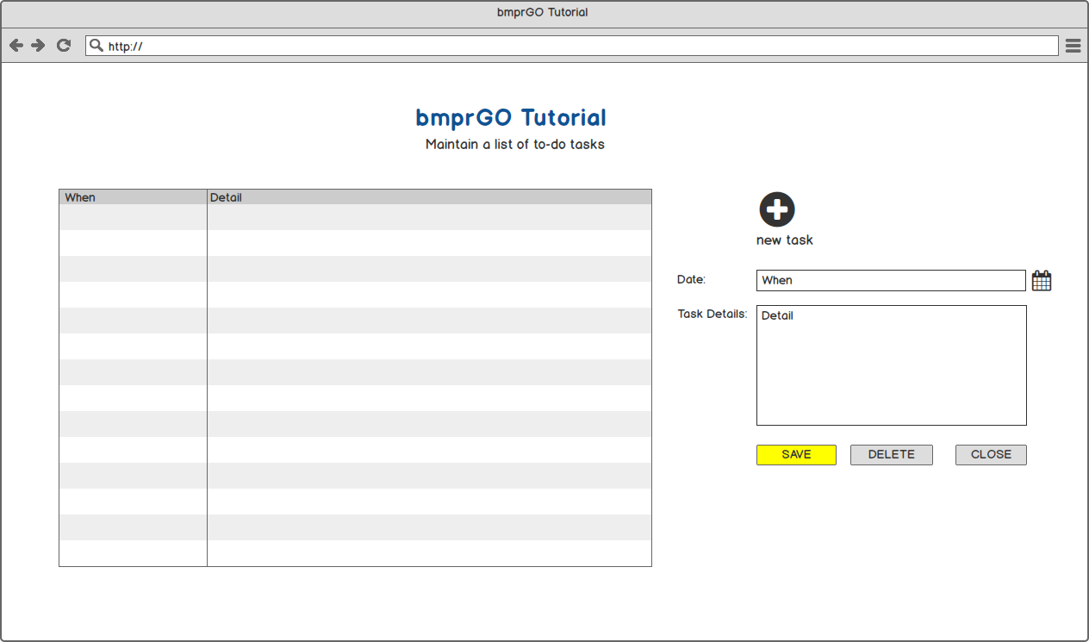

**End of Start.Form**

### Start_Phone.Form Details.Form

Load ToDo

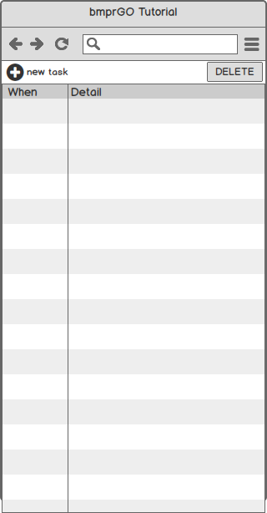 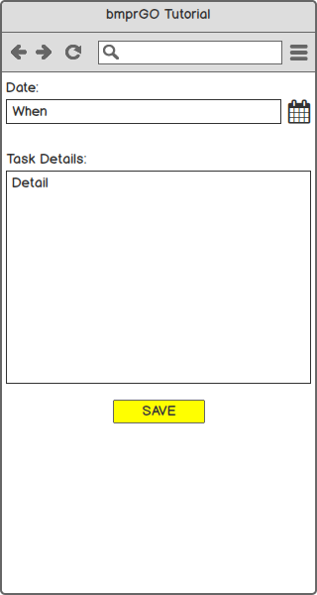

**End of Start_Phone.Form End of Details.Form**

*We need 2 forms to deliver the same functionality on the phone.*

**End of Host**

**End of Specification**